

Project Increment -1

Tech Roos Team(Aditya Deshpande, Rakesh Reddy Kondakindi,Tej Kiran Meka,Girish babu)

**Introduction:**

Instacharity acts as a mediator between donors and organizations. Through this site donors can easily access through the information of the organizations and help organizations by donating money. Main advantage of this website is that donors can access different organizations in less amount of time.

In First Increment we designed registration services, login services, nunit test cases and UI design.

**Technologies Used:**

* **Coding Language:** C# , ASP.NET
* **Testing:** Nunit Testing
* **Local Database:** SQL Server 2012
* **Remote Database:** SQL Server 2012
* **Tools:** Microsoft Visual Studio 2012

**Detail Design of Services:**

**WSDL : Service Description:**

The WSDL service description of the services is given below

<wsdl:definitions xmlns:tm="http://microsoft.com/wsdl/mime/textMatching/" xmlns:soapenc="http://schemas.xmlsoap.org/soap/encoding/"xmlns:mime="http://schemas.xmlsoap.org/wsdl/mime/" xmlns:tns="http://tempuri.org/" xmlns:soap="http://schemas.xmlsoap.org/wsdl/soap/"xmlns:s="http://www.w3.org/2001/XMLSchema" xmlns:soap12="http://schemas.xmlsoap.org/wsdl/soap12/" xmlns:http="http://schemas.xmlsoap.org/wsdl/http/"xmlns:wsdl="http://schemas.xmlsoap.org/wsdl/" targetNamespace="http://tempuri.org/">

<wsdl:types>

<s:schema elementFormDefault="qualified" targetNamespace="http://tempuri.org/">

<s:element name="User_Registration">

<s:complexType>

<s:sequence>

<s:element minOccurs="0" maxOccurs="1" name="firstname" type="s:string"/>

<s:element minOccurs="0" maxOccurs="1" name="lastname" type="s:string"/>

<s:element minOccurs="0" maxOccurs="1" name="emailid" type="s:string"/>

<s:element minOccurs="0" maxOccurs="1" name="password" type="s:string"/>

</s:sequence>

</s:complexType>

</s:element>

<s:element name="User_RegistrationResponse">

<s:complexType>

<s:sequence>

<s:element minOccurs="0" maxOccurs="1" name="User_RegistrationResult" type="s:string"/>

</s:sequence>

</s:complexType>

</s:element>

<s:element name="User_Login">

<s:complexType>

<s:sequence>

<s:element minOccurs="0" maxOccurs="1" name="emailid" type="s:string"/>

<s:element minOccurs="0" maxOccurs="1" name="password" type="s:string"/>

</s:sequence>

</s:complexType>

</s:element>

<s:element name="User_LoginResponse">

<s:complexType>

<s:sequence>

<s:element minOccurs="0" maxOccurs="1" name="User_LoginResult" type="s:string"/>

</s:sequence>

</s:complexType>

</s:element>

<s:element name="Organization_Registration">

<s:complexType>

<s:sequence>

<s:element minOccurs="0" maxOccurs="1" name="emailid" type="s:string"/>

<s:element minOccurs="0" maxOccurs="1" name="name" type="s:string"/>

<s:element minOccurs="0" maxOccurs="1" name="address" type="s:string"/>

<s:element minOccurs="0" maxOccurs="1" name="password" type="s:string"/>

</s:sequence>

</s:complexType>

</s:element>

<s:element name="Organization_RegistrationResponse">

<s:complexType>

<s:sequence>

<s:element minOccurs="0" maxOccurs="1" name="Organization_RegistrationResult" type="s:string"/>

</s:sequence>

</s:complexType>

</s:element>

<s:element name="Organization_Login">

<s:complexType>

<s:sequence>

<s:element minOccurs="0" maxOccurs="1" name="emailid" type="s:string"/>

<s:element minOccurs="0" maxOccurs="1" name="password" type="s:string"/>

</s:sequence>

</s:complexType>

</s:element>

<s:element name="Organization_LoginResponse">

<s:complexType>

<s:sequence>

<s:element minOccurs="0" maxOccurs="1" name="Organization_LoginResult" type="s:string"/>

</s:sequence>

</s:complexType>

</s:element>

</s:schema>

</wsdl:types>

<wsdl:message name="User_RegistrationSoapIn">

<wsdl:part name="parameters" element="tns:User_Registration"/>

</wsdl:message>

<wsdl:message name="User_RegistrationSoapOut">

<wsdl:part name="parameters" element="tns:User_RegistrationResponse"/>

</wsdl:message>

<wsdl:message name="User_LoginSoapIn">

<wsdl:part name="parameters" element="tns:User_Login"/>

</wsdl:message>

<wsdl:message name="User_LoginSoapOut">

<wsdl:part name="parameters" element="tns:User_LoginResponse"/>

</wsdl:message>

<wsdl:message name="Organization_RegistrationSoapIn">

<wsdl:part name="parameters" element="tns:Organization_Registration"/>

</wsdl:message>

<wsdl:message name="Organization_RegistrationSoapOut">

<wsdl:part name="parameters" element="tns:Organization_RegistrationResponse"/>

</wsdl:message>

<wsdl:message name="Organization_LoginSoapIn">

<wsdl:part name="parameters" element="tns:Organization_Login"/>

</wsdl:message>

<wsdl:message name="Organization_LoginSoapOut">

<wsdl:part name="parameters" element="tns:Organization_LoginResponse"/>

</wsdl:message>

<wsdl:portType name="WebserviceSoap">

<wsdl:operation name="User_Registration">

<wsdl:input message="tns:User_RegistrationSoapIn"/>

<wsdl:output message="tns:User_RegistrationSoapOut"/>

</wsdl:operation>

<wsdl:operation name="User_Login">

<wsdl:input message="tns:User_LoginSoapIn"/>

<wsdl:output message="tns:User_LoginSoapOut"/>

</wsdl:operation>

<wsdl:operation name="Organization_Registration">

<wsdl:input message="tns:Organization_RegistrationSoapIn"/>

<wsdl:output message="tns:Organization_RegistrationSoapOut"/>

</wsdl:operation>

<wsdl:operation name="Organization_Login">

<wsdl:input message="tns:Organization_LoginSoapIn"/>

<wsdl:output message="tns:Organization_LoginSoapOut"/>

</wsdl:operation>

</wsdl:portType>

<wsdl:binding name="WebserviceSoap" type="tns:WebserviceSoap">

<soap:binding transport="http://schemas.xmlsoap.org/soap/http"/>

<wsdl:operation name="User_Registration">

<soap:operation soapAction="http://tempuri.org/User_Registration" style="document"/>

<wsdl:input>

<soap:body use="literal"/>

</wsdl:input>

<wsdl:output>

<soap:body use="literal"/>

</wsdl:output>

</wsdl:operation>

<wsdl:operation name="User_Login">

<soap:operation soapAction="http://tempuri.org/User_Login" style="document"/>

<wsdl:input>

<soap:body use="literal"/>

</wsdl:input>

<wsdl:output>

<soap:body use="literal"/>

</wsdl:output>

</wsdl:operation>

<wsdl:operation name="Organization_Registration">

<soap:operation soapAction="http://tempuri.org/Organization_Registration" style="document"/>

<wsdl:input>

<soap:body use="literal"/>

</wsdl:input>

<wsdl:output>

<soap:body use="literal"/>

</wsdl:output>

</wsdl:operation>

<wsdl:operation name="Organization_Login">

<soap:operation soapAction="http://tempuri.org/Organization_Login" style="document"/>

<wsdl:input>

<soap:body use="literal"/>

</wsdl:input>

<wsdl:output>

<soap:body use="literal"/>

</wsdl:output>

</wsdl:operation>

</wsdl:binding>

<wsdl:binding name="WebserviceSoap12" type="tns:WebserviceSoap">

<soap12:binding transport="http://schemas.xmlsoap.org/soap/http"/>

<wsdl:operation name="User_Registration">

<soap12:operation soapAction="http://tempuri.org/User_Registration" style="document"/>

<wsdl:input>

<soap12:body use="literal"/>

</wsdl:input>

<wsdl:output>

<soap12:body use="literal"/>

</wsdl:output>

</wsdl:operation>

<wsdl:operation name="User_Login">

<soap12:operation soapAction="http://tempuri.org/User_Login" style="document"/>

<wsdl:input>

<soap12:body use="literal"/>

</wsdl:input>

<wsdl:output>

<soap12:body use="literal"/>

</wsdl:output>

</wsdl:operation>

<wsdl:operation name="Organization_Registration">

<soap12:operation soapAction="http://tempuri.org/Organization_Registration" style="document"/>

<wsdl:input>

<soap12:body use="literal"/>

</wsdl:input>

<wsdl:output>

<soap12:body use="literal"/>

</wsdl:output>

</wsdl:operation>

<wsdl:operation name="Organization_Login">

<soap12:operation soapAction="http://tempuri.org/Organization_Login" style="document"/>

<wsdl:input>

<soap12:body use="literal"/>

</wsdl:input>

<wsdl:output>

<soap12:body use="literal"/>

</wsdl:output>

</wsdl:operation>

</wsdl:binding>

<wsdl:service name="Webservice">

<wsdl:port name="WebserviceSoap" binding="tns:WebserviceSoap">

<soap:address location="http://localhost:58528/Webservice.asmx"/>

</wsdl:port>

<wsdl:port name="WebserviceSoap12" binding="tns:WebserviceSoap12">

<soap12:address location="http://localhost:58528/Webservice.asmx"/>

</wsdl:port>

</wsdl:service>

</wsdl:definitions>

**Registration:**

**Class Diagram:**



**Sequence Diagram:**



**Login:**

**Class Diagram:**



**Sequence Diagram:**



**Implementation:**

In first Increment we designed login and registration services for donors and organizations. Designed UI for the website. And we designed nunit test cases for implementation of login and registration services.

**Database:**

We created a database with the following tables:

**Table 1:**

**Name: Registration**

In this table details of the donor's will be saved after the registration process.

There are

* **FirstName (string):**

First name entered by the donor will be stored.

* **LastName (string):**

Last name entered by the donor will be stored.

* **EmailId (string):**

Email Id entered by the donor will be stored.

* **Password (string):**

Password entered by the donor will be stored.

**Table 2:**

**Name: Organization_Registration**

In this table details of the organization will be stored after registration process.

**Name (string):**

Name of the organization given during registration process will be stored.

**Address (string):**

Address of the organization will be stored.

**EmailId (string):**

EmailId of the organization will be stored in this column.

**Password (string):**

Password given by the organization member will be stored in this column.

**Report:**

**Design of the services:**

Following screen shots are the design of webservice.

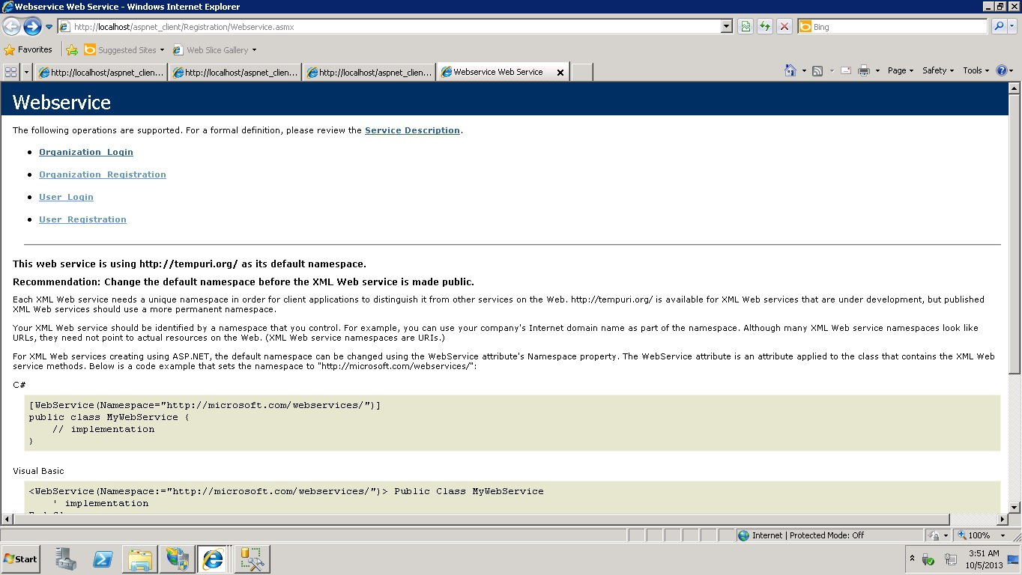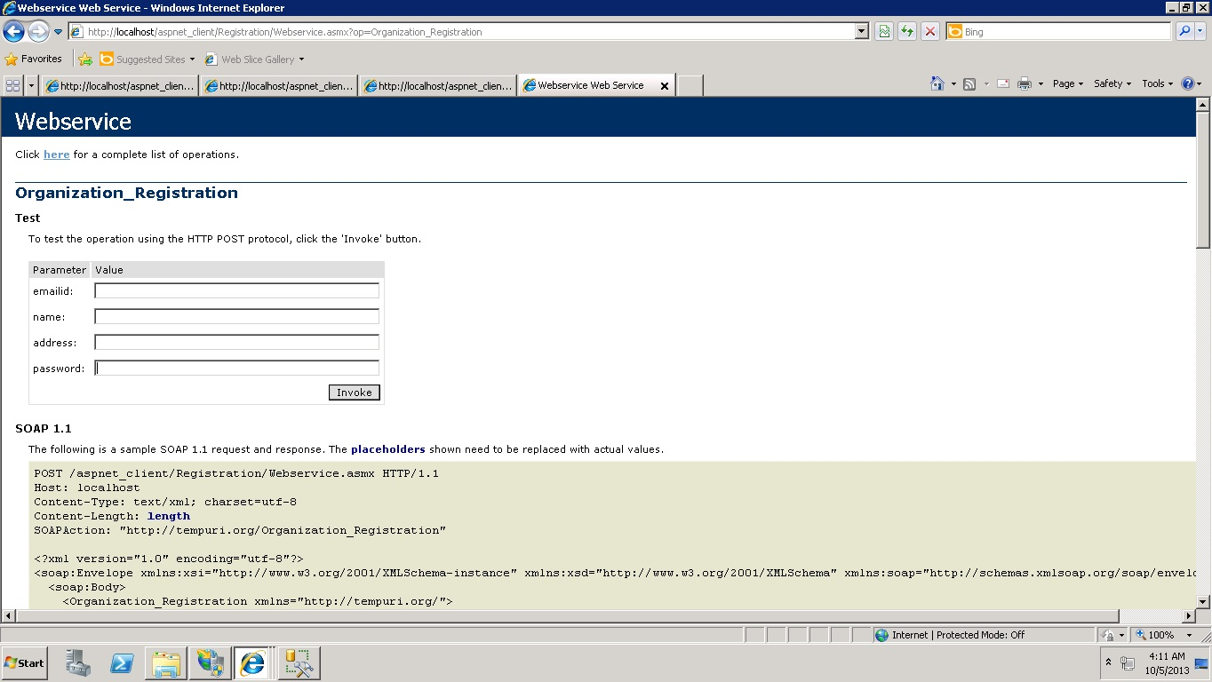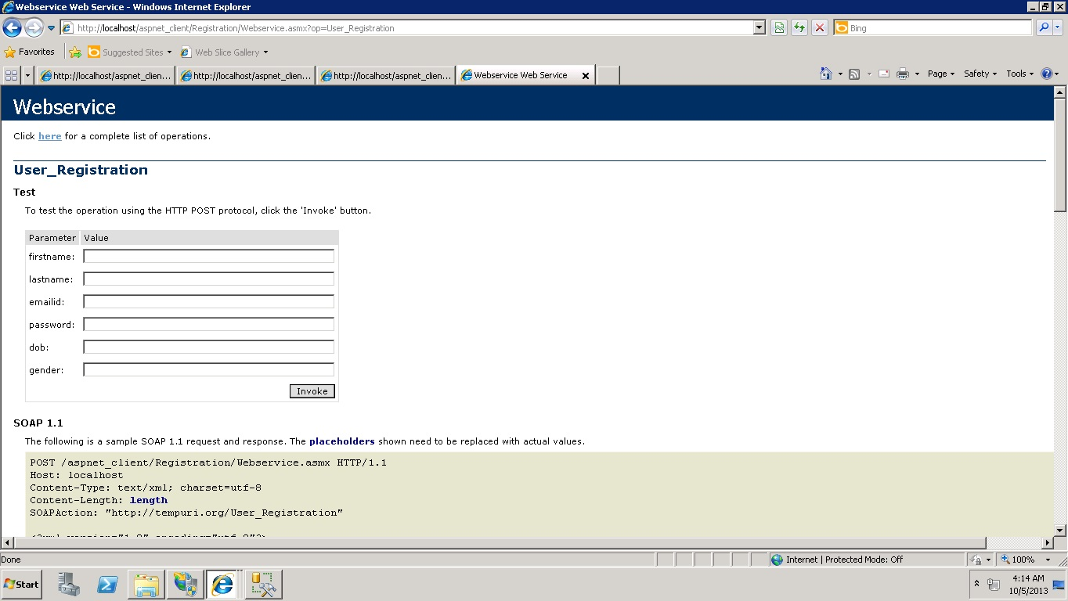

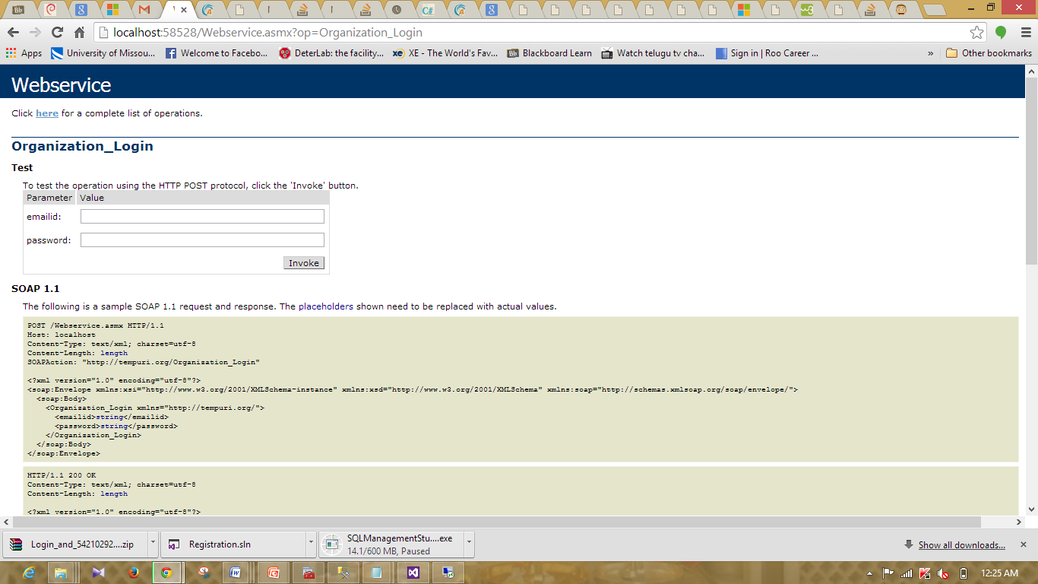

**Implementation of UI:**

The following screen shots are the basic navigations of the UI designed for the first Increment.

* **Home Page**

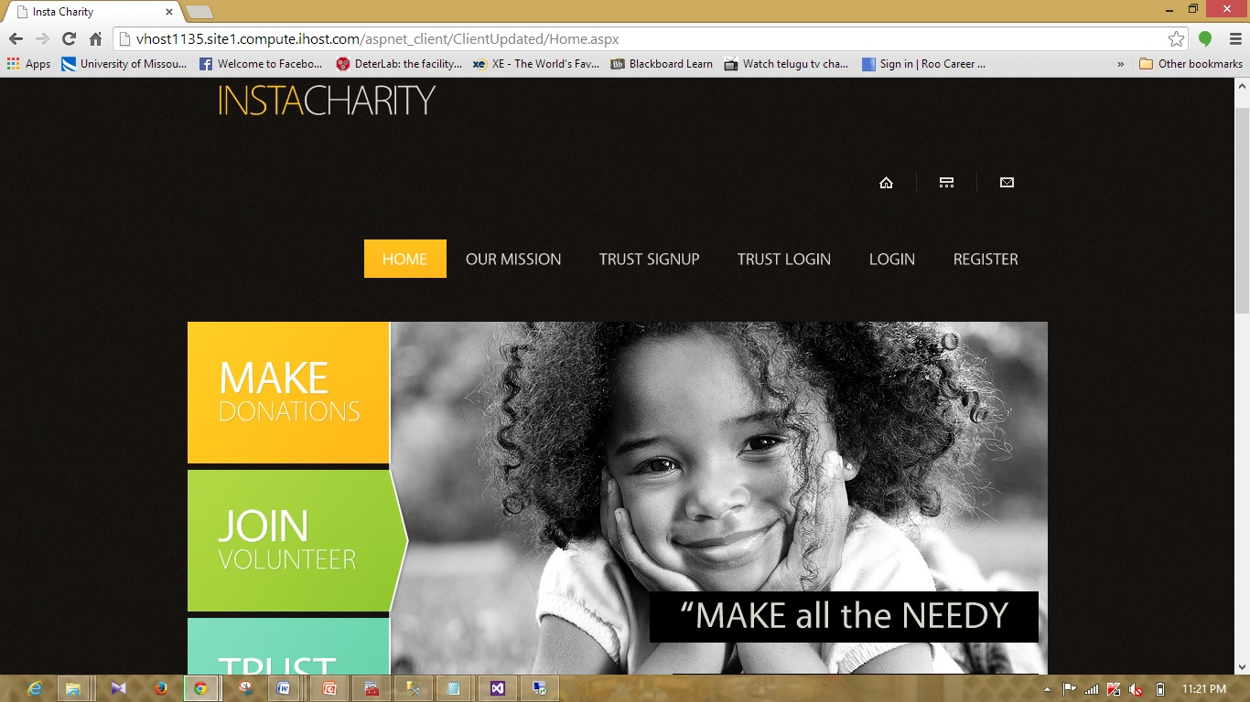

* **Our Mission**

We designed the basic page of our mission page. Content of the page will be updated soon.

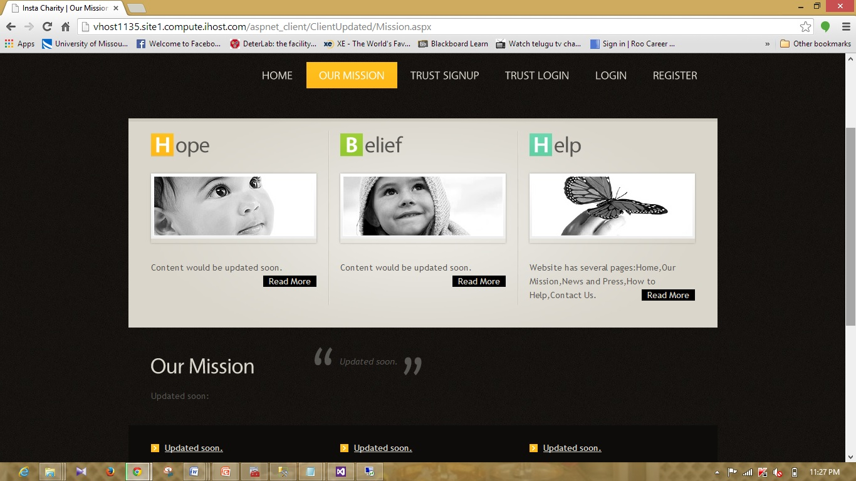

* **Trust Signup:**

This page enables organizations to register into the website.

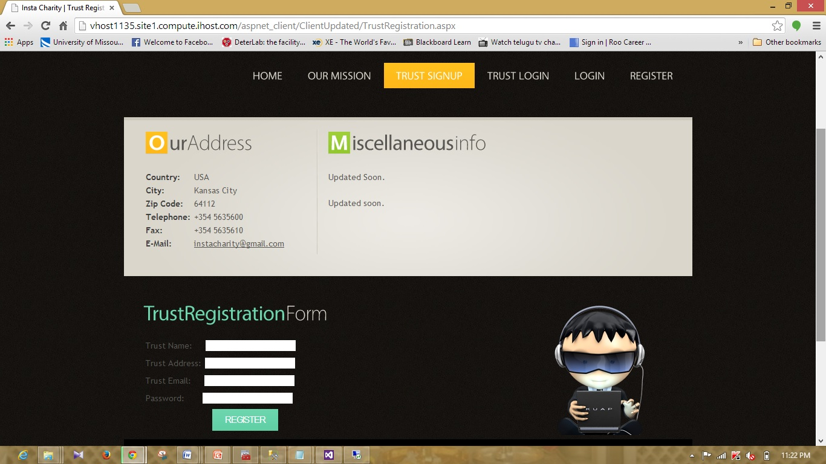

* **Trust Login:**

Through this page Organizations can login into the website.

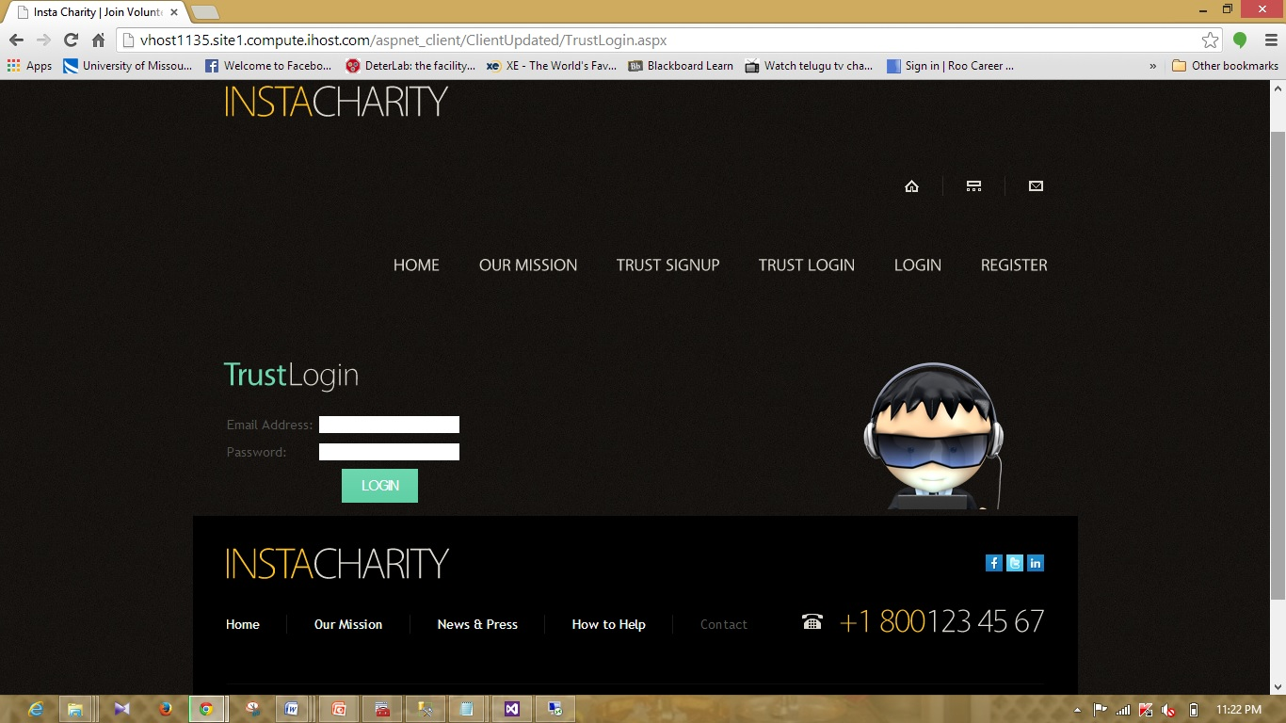

* **Login:**

Through this page Donors can login into the website.

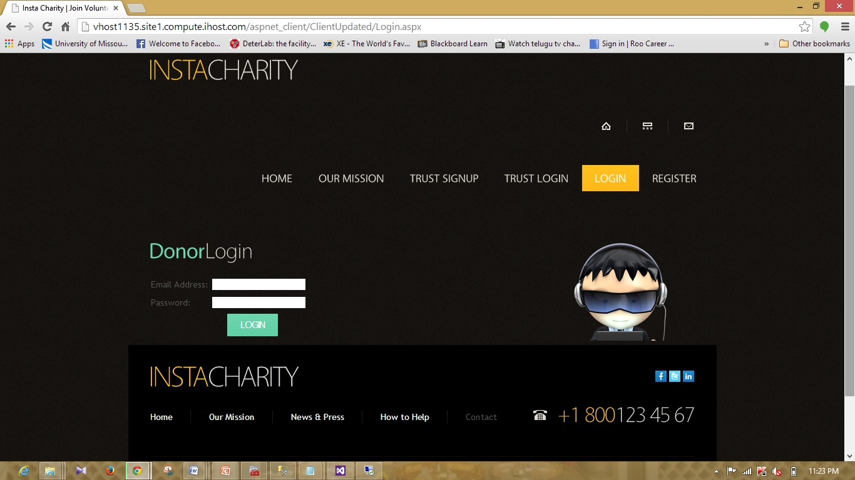

* **Register:**

Through this page donors can sign up into the instacharity website.

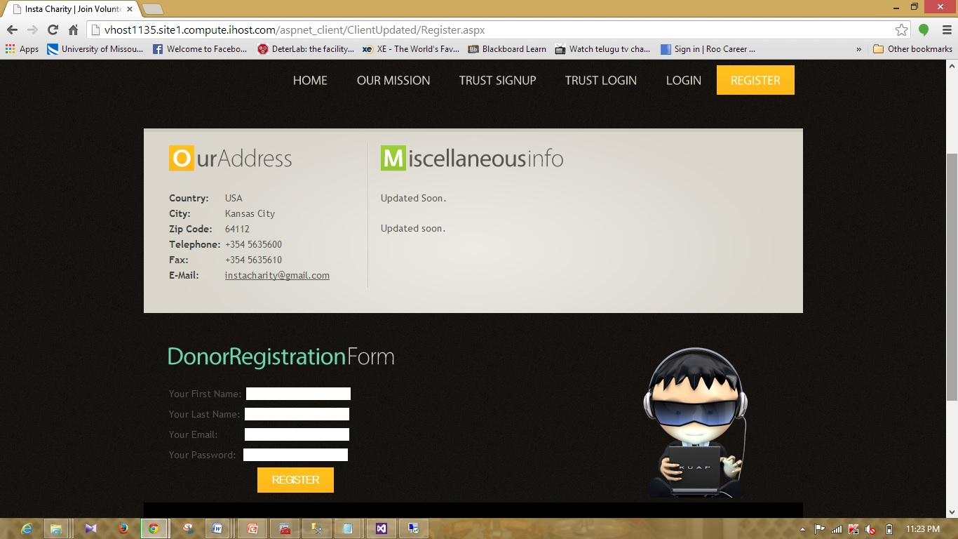

As part of the Login and Registration services of donors and organizations, we created validations for the services

**Organization Registration Service Validations:**

If organization representative leaves the fields empty during Signup, error messages will be retrieved on the page.

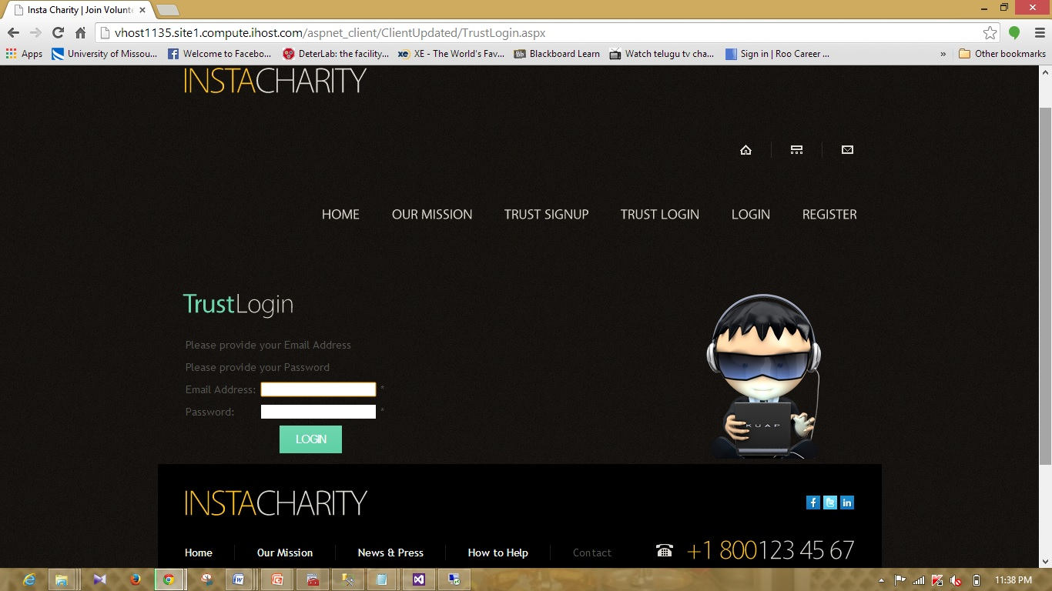

**Organization Login Validations:**

When Organization representative leaves the fields of the login page empty, then the following error messages will be retrieved on the web page.



**Donor's Login Validations:**

When Donor leaves the fields empty during login the following error messages will be retrieved on the website.

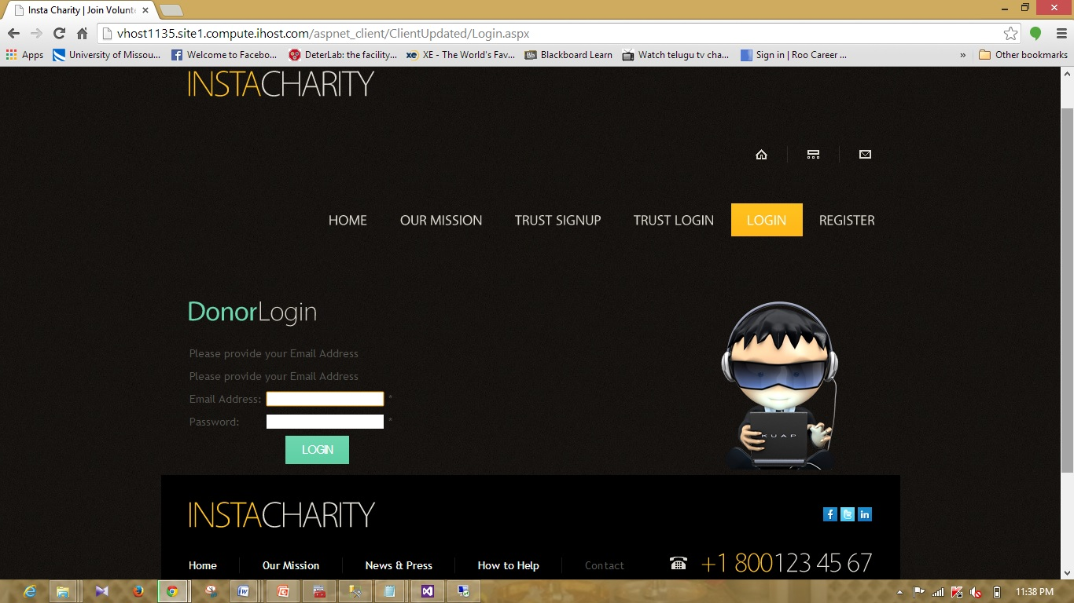

**Donor Registration Validations:**

When donor leaves the fields empty during registration then the following error messages will be retrieved on the web page.

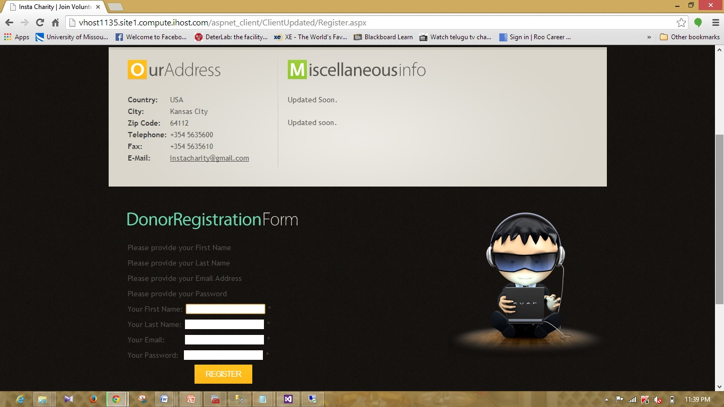

**Organization registration:**

The following screenshot is the Organization registration form. Organization member will enter the credentials and clicks on register button provided. Then credentials will be stored in DB.

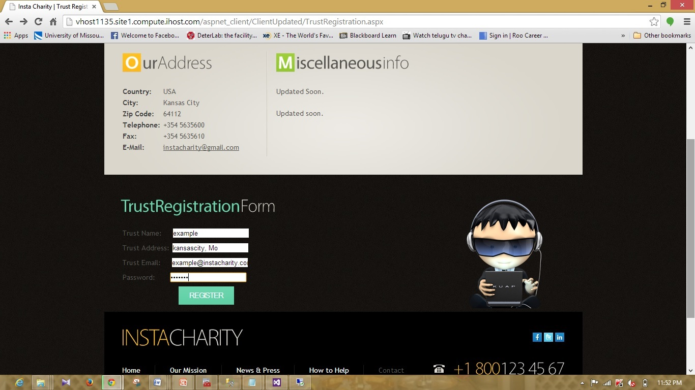

**Organization Login:**

Following slide represents the Login Page of the organization. Organization will fill the fields will the credentials registered with the website.

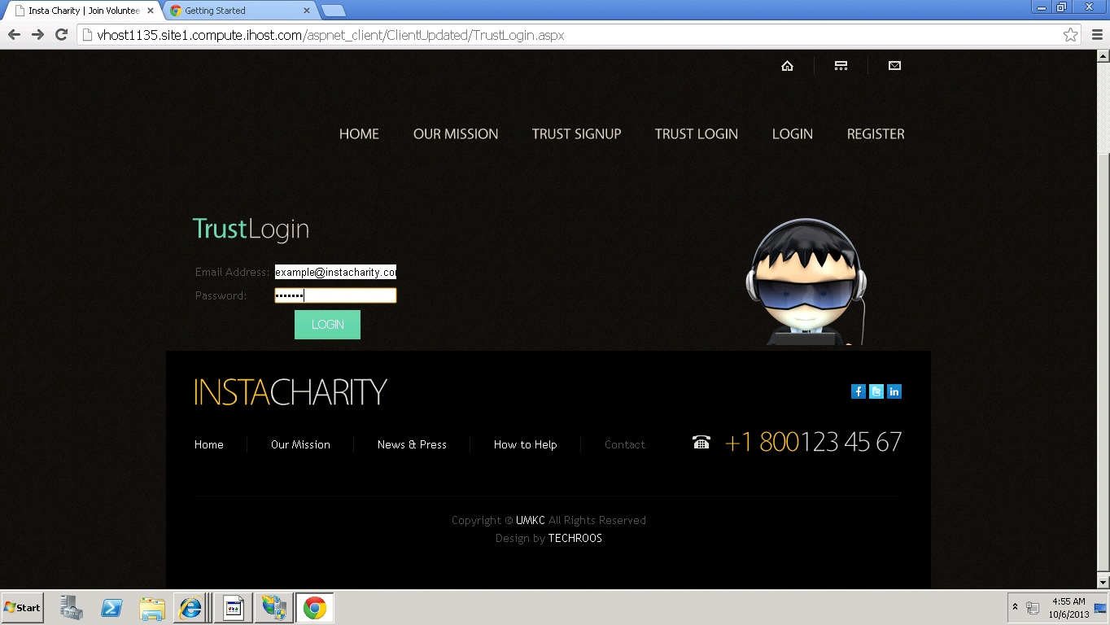

When the login credentials matches with the credentials in the database then the "login successful" message will be retrieved to the organization representative.

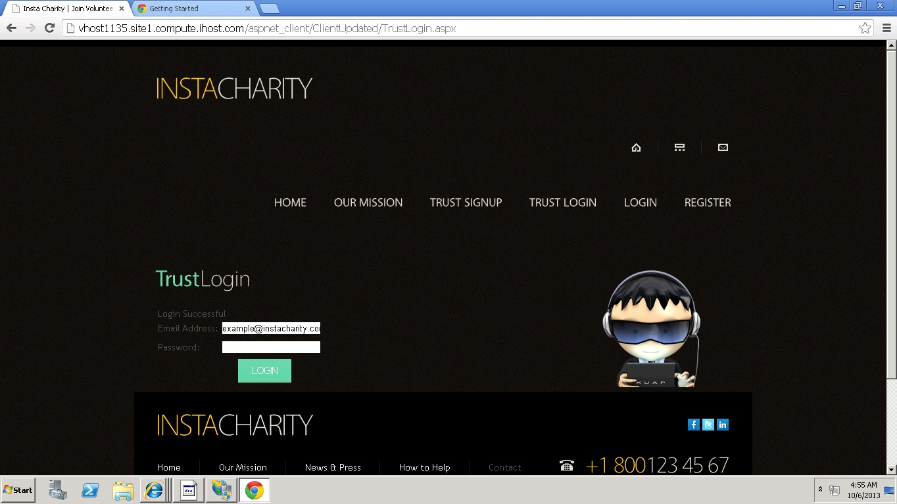

When the login credentials doesn't matches with the credentials in the database then the " Invalid Credentials" message will be retrieved to the organization representative.

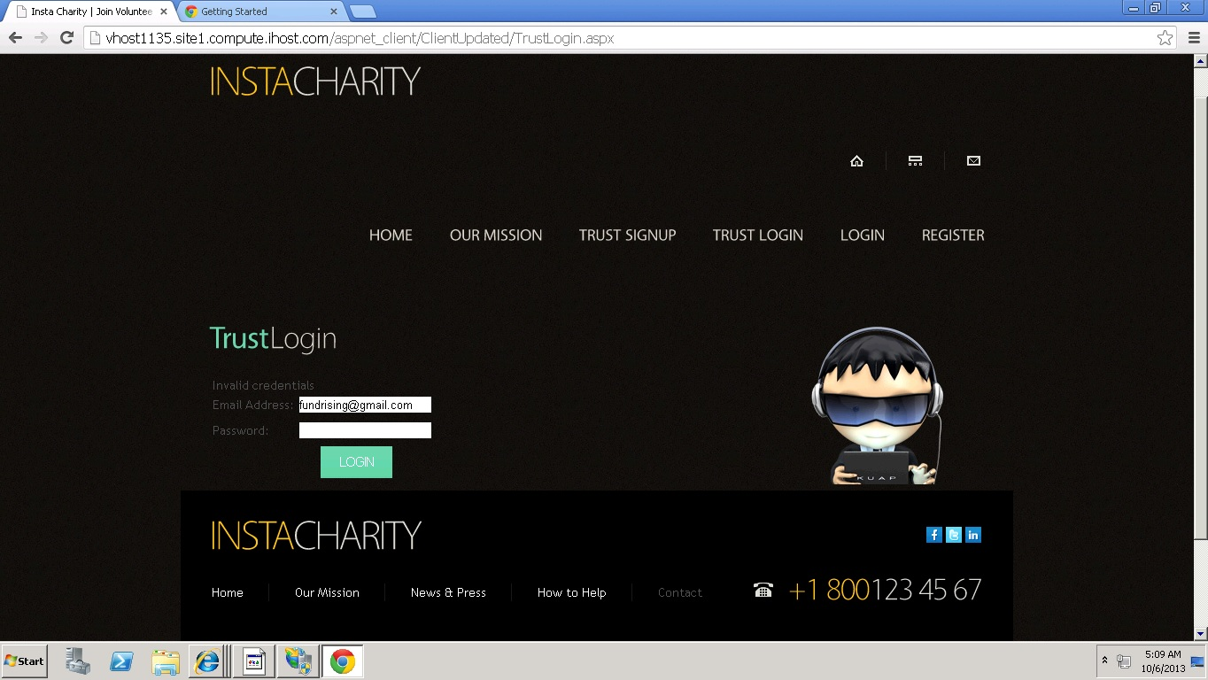

**Donor Registration:**

Donor's register into the website by filling his credentials on the website.

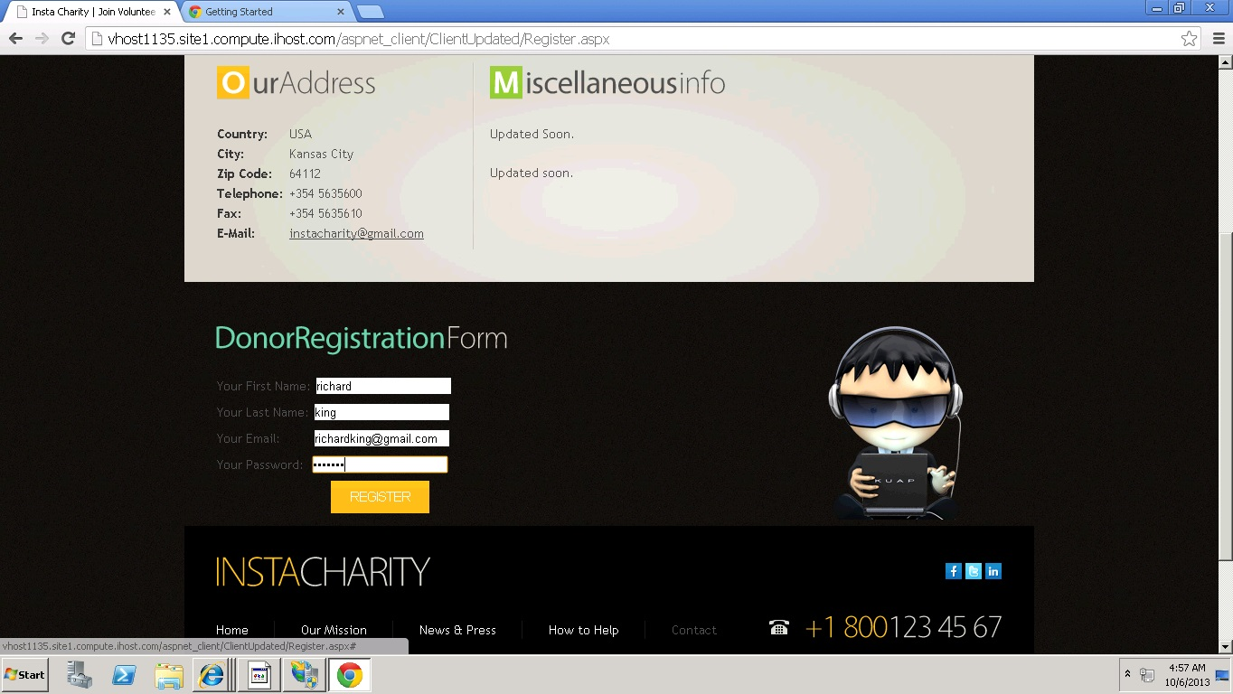

**Donor Login:**

Donor fill the fields with the credentials registered with the site on login page.

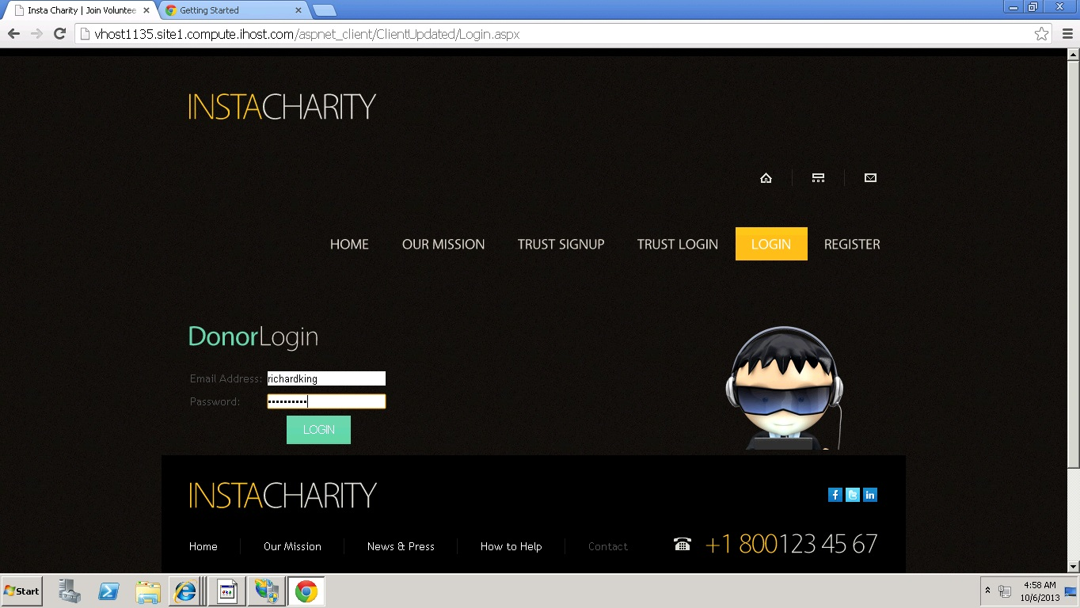

When the donor login with the credentials that are not registered with the site, the message "Invalid Credentials" will be retrieved to the donor.

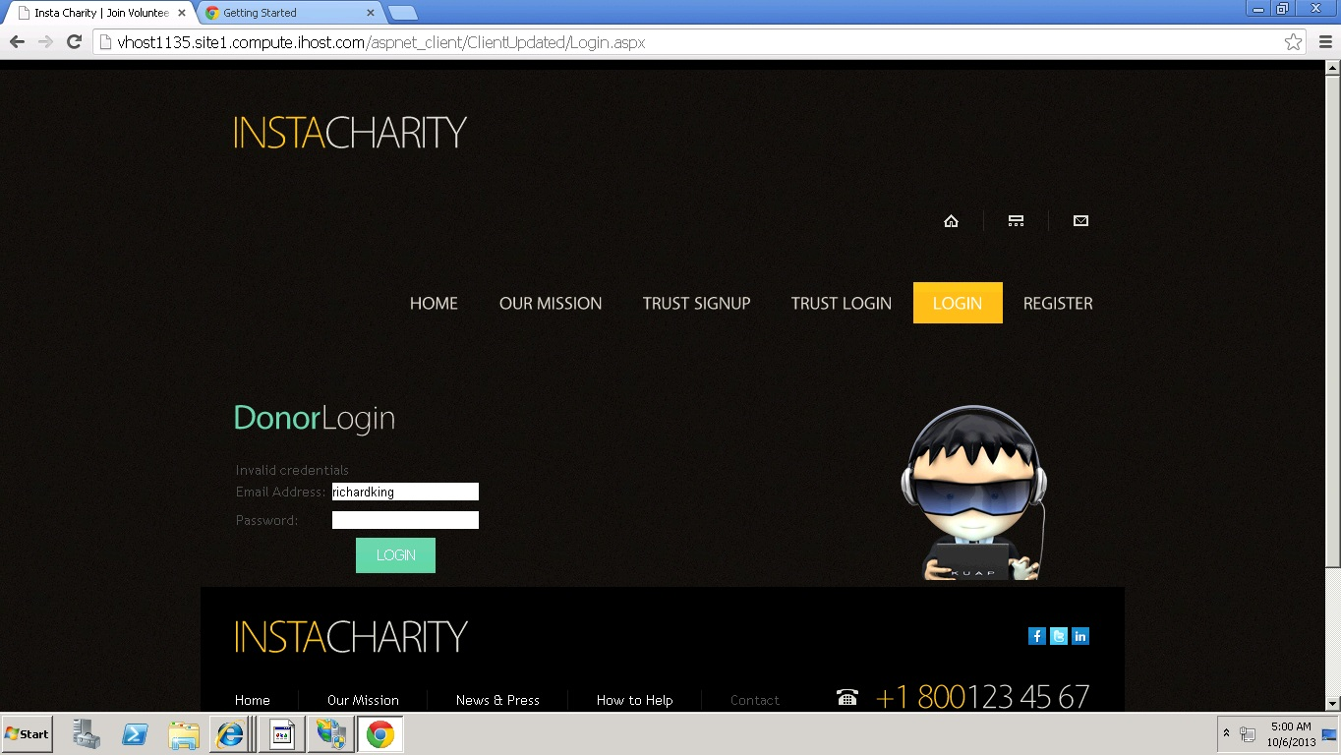

**Deployment:**

**Scrum Do URL:**

<http://www.scrumdo.com/projects/project/insta-charity/iteration/78011>

**Cloud URL:**

[http://vhost1135.site1.compute.ihost.com/aspnet_client/ClientUpdated/Home.aspx](http://vhost1135.site1.compute.ihost.com/aspnet_client/ASEProject/OrganizationLogin.aspx)

**Git hub URL:**

<https://github.com/instacharity/Instacharityproject/tree/master/Increment%201>

**Issues and concerns:**

We faced some database connectivity issues during the design and implementation of the project.